Journal of Experimental Psychology: Human Perception and Performance 1979, Vol. 5, No. 4, 674-691
The Organization and Activation of Orthographic Knowledge in Reading Aloud
Robert J. Glushko
University of California. San Diego
"Exception" words like have, with irregular spelling-to-sound correspondences, take longer to read aloud than words like haze, with regular correspondences. "Exception pseudowords" like tave, which resemble irregular words, suffer a similar penalty in pronunciation latency compared to "regular pseudowords" like taze, which resemble regular words. Finally, "regular but inconsistent" words like wave, which have regular spelling-to-sound structure but which resemble exception words, take longer to pronounce than "regular and consistent" words like wade. These results refute current claims that words are read aloud by retrieving a single pronunciation from memory and that pseudowords are pronounced by using abstract spelling-to-sound rules. Instead, it appears that words and pseudowords are pronounced using similar kinds of orthographic and phonological knowledge: the pronunciations of words that share orthographic features with them, and specific spelling-to-sound rules for multiletter spelling patterns. The traditional classification of words as regular and exception should be supplemented by a classification that incorporates the "consistency" or "inconsistency" of the orthographic knowledge activated in the course of pronouncing a word.

Reading- aloud is a valuable skill, and most people learn to read by first learning to read aloud. The plausibility and success of reading aloud as a criterion measure in reading makes it natural for experimental psychologists to adopt pronunciation and naming tasks to study the information-processing components they share with word recognizing and reading. In particular, pronunciation is a reasonable task in which to deter

This research was supported primarily by National Science Foundation Grant BMS 76-15024 to David E. Rumelhart. The author held a National Science Foundation Graduate Fellowship while the research was conducted. Experiment 1 was presented at the 18th annual meeting of the Psycho-nomic Society in Washington, D.C-, in November 1977. This article was improved by careful readings by Jon Baron, Dave Bauer, Bob Buhr, Jeff Elman, Ray Gibbs, Mark Jackson, Jay McClelland, Paul Rosenbloom, Dave Rumelhart, and Arty Samuel. Jeff Miller provided valuable statistical advice.
Requests for reprints should be sent to Robert J. Glushko, who is now at Bell Laboratories, Whippany Road, Wbippany, New Jersey 07981.
mine what readers know about the orthography and phonology of their language and to study how they use this knowledge.¹
Most researchers who study reading and pronunciation share the idea that readers use spelling-to-sound rules to pronounce letter strings for which they do not have stored pronunciations (e.g., Baron & Straw-son, 1976; Forster & Chambers, 1973; Fred-

1. Even though reading aloud is certainly not the same as reading in all respects, even fluent readers sometimes access the meanings of printed words using a phonological code (see Baron, 1977a; Bradshaw, 1975). Skilled lexical access can take place rapidly using nonphonological addressing (see Coltheart, 1978; Meyer, Schvaneveldt, & Ruddy, 1974). However, even if phonological access were always slower, it could still be an important source of confirming evidence in word recognition (see Marshall, 1976). In addition, many researchers treat reading and reading aloud as equivalent tasks for testing models of word recognition (e.g., Gough & Cosky, 1977; Meyer, Schvaneveldt, & Ruddy, 1974; Spoehr & Smith, 1975; Theios & Muise, 1977).

eriksen & Kroll, 1976; Gough & Cosky, 11977; Mason, 1978). These researchers generally posit a rule-based or orthographic [mechanism to complement a word-specific or lexical mechanism that retrieves the stored I pronunciation of a familiar word. Rules are often characterized as explicit knowledge lot mappings from letters or letter units to phonemes (e.g., B —>/b/, EA —>/i/) or of abstract relational principles (e.g., a terminal e is a marker for the "free" or "long" correspondence for a preceding vowel).It is generally assumed that pseudowords are pronounced by these spelling-to-sound rules operating alone. When (or as) the letters in a novel letter string are identified by the letter analysis procedures, the relevant rules operate to assign the appropriate pronunciation to the letters or letter units in the string.
In this article I propose to revise the roles assigned to these lexical and orthographic procedures; the traditional distinction between them as the primary mechanisms of I word and pseudoword pronunciation is blurred by evidence here that both procedures can work together to pronounce either kind of letter string. Indeed, the lexical and orthographic procedures hardly differ in the knowledge that they use; it may be more appropriate to study the respective knowledge bases without assuming that separate mechanisms exist at all. There is no clear evidence here for the use of abstract orthographic rules as they are typically proposed; to the extent that rules are used at all in naming tasks, they contain specific correspondences for multiletter spelling patterns that are difficult to distinguish from entire words retrieved as wholes.
Three Kinds of Orthographic Rules
Progress toward a theoretical and practical understanding of orthographic processing in reading has been impeded by the inconsistent use of three different conceptions of orthographic rules: (a) rules as linguistic descriptions; (b) rules as knowledge of language structure; and (c) rules as procedures or mechanisms of pronunciation. Many researchers incorrectly assume that rules of the first kind imply rules of the second kind, and that rules of the second kind can be assessed independently of rules of the third kind. I shall consider each of these misinterpretations in turn.
Linguistic descriptions versus linguistic knowledge. Many models of reading aloud propose that readers use complex context-sensitive grapheme-phoneme rules such as those developed by Wijk (1966) and Venezky (1970). Nevertheless, there is no necessary relationship between linguistic descriptions of the orthographic and phonological regularity in the language and a reader's knowledge of such language structure. Since each word in the language is weighted equally in deciding whether a correspondence is regular or not, descriptive rules like these would be extremely difficult for readers to induce. Reading researchers who suggest that readers use rules of this type have ignored Venezky's (1967) own admonition: "It is inconceivable that any human could without special effort arrive at the same rules" (p. 102).
Linguistic rule systems often incorporate historical and morphological regularity as well as spelling-to-sound regularity, but many of these rules have no place in psychological models. While such regularity is important in a complete linguistic description of English, it is of little use to a reader who encounters the word for the first time. Readers may know a great deal about the spelling-to-sound structure of their language, and linguistic descriptions can be sources of hypotheses about what this knowledge might be, but whether readers know the rules and whether they encode this knowledge as rules remain empirical issues.
Inseparability of representation and process. Some researchers assume that they can experimentally assess a reader's knowledge of orthography and phonology independently of the processes or procedures that use that knowledge. These researchers propose that readers know the rules of spelling-to-sound correspondence, and they then characterize the properties of a specialized orthographic mechanism that makes use of these rules. Nevertheless, this is only one of a large number of different partitions of the
overall orthographic and phonological knowledge system into "memory" and "process" parts, and experimental evidence alone is incapable of distinguishing among these parts. It is premature to take this particular representation-process pair as the most appropriate ; in fact, given the conditions under which people learn to read, and the varied uses to which they put their knowledge of spelling-to-sound correspondences, it may be less optimal to have a specialized and separate orthographic processor rather than some general, content-free retrieval process.
I am not claiming that separate study of linguistic knowledge and linguistic mechanisms is impossible. In principle, clinical evidence from brain-damaged aphasics, in who disorders of speech production coexist with intact auditory language comprehension, might distinguish between memories and processes. In these cases, for example, it would seem that a mechanism that uses phonological knowledge is disrupted, even though the actual memory representation remains undamaged. However, a number of "unclear" cases of aphasia in which both comprehension and production are impaired, make the "clear" cases less useful (see Zurif & Caramazza, 1976).
Models of Reading Aloud
Researchers who study reading and pronunciation have not always recognized the distinction between linguistic descriptions and linguistic knowledge and the inseparability of linguistic knowledge and linguistic mechanisms. Thus, it is useful to review previous proposals for the representation and use of orthographic structure with these important points in mind.
Pronunciation by Spelling-to-Sound Rules
There are four results that underlie the traditional claim that orthographic rules are used in reading aloud. While these data are consistent with the idea that an orthographic mechanism uses spelling-to-sound rules, I suggest a more restricted interpretation of these results: They are evidence for the use of orthographic knowledge, but do not suggest how this knowledge of linguistic structure is represented in memory and do no; specify the linguistic mechanisms that use that knowledge. I shall account for these four results without reference to knowledge in the form of rules or rule mechanisms of any kind.
Pseudowords take longer to read on the average than words. (See Forster & Chambers, 1973, and Frederiksen & Kroll, 1976, for examples.) Letter strings for which complete pronunciations cannot exist in memory must be pronounced by constructing a pronunciation from other sources of orthographic and phonological knowledge. This construction, or synthesis, is usually slower than the direct retrieval of a complete articulatory program for a familiar word.
"Exception" words, which "break the rules," take longer to read than "regular" words. (See Baron & Strawson, 1976; Gough & Cosky, 1977; and Stanovich & Bauer, 1978, for examples.) Exception words are, by definition, inconsistent with the general principles of the spelling-to-sound structure of the language. If a reader's knowledge of this structure incorporates similar principles, then exception words are also inconsistent with any general knowledge that might be used to construct a pronunciation for an unfamiliar letter string. Therefore, exception words must be pronounced by retrieving specific stored knowledge of their pronunciations, and these stored pronunciations might conflict with knowledge of regularity activated at the same time. Thus, exceptions are pronounced more slowly than regular words, which can be pronounced by retrieving specific pronunciations and/or by synthesis from knowledge of spelling-to-sound correspondences, since these two sources of knowledge are consistent for regular words.
Individual differences in orthographic and lexical knowledge. A third pattern of results from which researchers postulate the use of orthographic rules has arisen in studies of individual differences in reading (Baron, 1979; Baron & Strawson, 1976). Baron and Strawson located adult readers who relied primarily on word-specific knowledge in pronunciation and spelling, whom they called "Chinese" (since, presumably, actual readers of Chinese do the same).
These Chinese readers differed on a number of latency and error measures from "Phoenicians," who relied on knowledge of spelling-to-sound correspondences. Baron has recently reported that the same two classes of readers exist in child populations. These individual differences might result from differences in instruction, which might produce different orthographic knowledge bases, or from differences in strategy, which might involve different ways of using the same knowledge.
Clinical evidence from studies of aphasics. A fourth body of results that has been taken as evidence for the use of spelling-to-sound rules in normal reading comes from studies of aphasic patients who acquired reading disabilities after brain injuries (e.g., Marshall, 1976; Patterson & Marcel, 1977; Saffran & Marin, 1977). Patients classified as "deep" or "phonemic" dyslexics are unable to pronounce pseudowords at all, even though they can correctly pronounce familiar words. It is permissible to infer that such patients have lost access to their knowledge of spelling-to-sound correspondences, but it is merely a conjecture that such knowledge was stored as grapheme-to-phoneme rules.
Pronunciation by Analogy
Suppose a reader encounters the pseudo-word vate and the response is /vet/ so as to rhyme with rate. Although this pronunciation could be produced by abstract grapheme-phoneme rules, it might instead have been based on a more specific rule using the multiletter correspondence of the familiar -ate pattern, or by ^analogy with a word like gate... Therefore, much of the evidence cited in support of abstract rules in reading aloud is equally consistent with the idea that readers use larger and more specific units of orthographic and phonological structure. This indeterminacy has led several researchers to consider whether a process of analogy can better account for the ability of readers to deal with novel forms.
An orthographic mechanism that uses analogies with existing words need not always predict the same pronunciations as abstract rules. Ohala (1974) had people generate novel pronunciations for which analogies and rules make conflicting predictions to determine the generality with which people use orthographic and phonological regularity. Smith and Baker (1975), Baker and Smith (1976), and Steinberg and Krohn (1975) also used this conflict or rivalry technique to compare analogical phonological rules with the abstract rules of Chomsky and Halle’s (1968) generative phonology. In all these experiments, people apparently used exception words as analogies to generate novel pronunciations that "broke the rules."
Baron (1977a, 1977b, 1979) recently presented demonstrations that readers can use analogies in reading aloud. Baron defined analogy as a conscious strategy of recalling a similar word and then modifying its pronunciation. He found (Baron, 1977b, Experiment 1) that adult readers reported the conscious use of analogies in "giving the best pronunciation" to a pseudoword, and that subjects who volunteered an analogy strategy did slightly better than those who did not. In addition, subjects became more successful at pronouncing pseudowords when they were given explicit analogy instructions (Baron. 1977b, Experiment 2). This improvement with analogy instruction also occurred with elementary school children (Baron. 1979, Experiment 3).
Brooks (1977a, 1977b, 1978) has proposed a rather different form of an analogy procedure for pronouncing novel words. Brooks's analogical mechanism operates implicitly rather than explicitly as does Baron's; since words that look alike tend to sound alike, readers might pronounce novel words by generalization from existing words with-.out any awareness of the spelling-to-sound correspondences in either letter string. Brooks (1978) recently argued that the conditions under which people learn to read encourage the learning of examples and discourage the learning of explicit rules of spelling-to-sound correspondence.
Pronunciation by Activation and Synthesis
The variety of different proposals for how readers might represent and use orthographic and phonological knowledge nicely
illustrates the two points I have tried to make in this introduction. First, the fact that English spelling is roughly phonemic does not mean that a reader who knows the relationship between print and sound will necessarily use the alphabetic principle in assigning pronunciations to letter strings. Second, there is a fundamental indeterminacy in efforts to identify the mechanisms that make use of knowledge of spelling-to-sound correspondences and the pronunciations of existing words; a large number of representation-process pairs may be equivalent in their functional properties. I suggest that it is more appropriate to focus on the functional properties of the lexical and orthographic knowledge bases, and to replace the unnecessarily specified mechanisms with a more neutral term such as "activation."
In this simpler framework, I propose that words and pseudowords are pronounced through the integration of orthographic and phonological information from a number of sources that are activated in parallel, much as readers comprehend sentences by integrating lexical, syntactic, and contextual information. As letter strings are identified, there is parallel activation of orthographic and phonological knowledge from a number of sources in memory. This knowledge may include the stored pronunciation of the letter string, pronunciations of words that share features with the letter string, and information about the spelling-to-sound correspondence of various subparts of the letter strings. A pronunciation is generated using procedures for determining how to modify the activated information in order to synthesize the desired articulatory program.
Experiment 1
The activation and synthesis proposal for the use of orthographic and phonological knowledge is consistent with the four important results that traditionally have been taken as support for the representation and use of grapheme-phoneme rules. However, this new explanation does not make a sharp distinction between the lexical and orthographic knowledge bases and does not assume that knowledge of spelling-to-sound regularity is organized solely as abstract rules. This change in emphasis suggests two interrelated questions that have been hidden from the approaches that began with the assumption of separate mechanisms for word-specific and grapheme-phoneme knowledge.
First, can words and pseudowords be pro- nounced using similar kinds of knowledge: Second, what is the level of generality of this knowledge? Is it an abstract representation of the most general principles of spelling-to-sound correspondence, or does it consists of al large number of specific correspondences for multiletter spelling units or complete words?! In an activation framework the difference between the pronunciation of words and pseudowords is only quantitative; words are generally pronounced using larger units (up to the entire letter string) than pseudowords, which might be parsed into smaller units to activate analogies or specific spelling-to-sound correspondences.
If abstract orthographic rules alone are used to pronounce pseudowords, then all pronounceable pseudowords should be read aloud with spelling-to-sound correspondences that are regular (cf. Frederiksen & Kroll, 1976; Gough & Cosky, 1977). For example, the pseudowords heaf and hean would be assigned the regular pronunciations /hif/ and /hin/. However, if existing words are retrieved during the pronunciation of pseudowords, then exception words that resemble pseudowords may affect their pronunciation. Since deaf, an orthographic exception, shares features with heaf, the analogy or activation proposals predict that heaf might occasionally be pronounced as /hef/, with the irregular correspondence in deaf. The activation conception also makes latency predictions for i the four kinds of letter strings in Experiment 1: Pronunciation latency will be greater when the orthographic knowledge activated is inconsistent, as it is for exception words and exception pseudowords, than when the knowledge uniquely determines a pronunciation, as it does for regular words and regular pseudowords. In their current form, the suggestions of analogical pronunciation made by Baron and Brooks make no latency predictions.
Method
Table 1
Results of Experiment

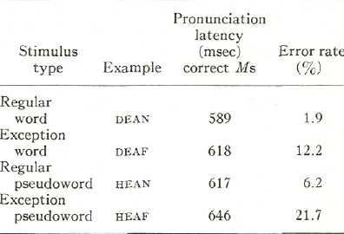
Subjects. Twelve students at the University of California, San Diego, received course credit or pay for the 30-min experimental session. All subjects were native speakers of English and had normal speech and hearing.
Stimuli and design. The stimuli were generated from a set of 43 monosyllabic orthographic exception words (e.g., deaf). Exception words are words with different spelling-to-sound correspondences than most words with the same vowel and terminal consonants. Whenever possible, a regular word was selected (e.g., DEAN) that differed from the exception only in its terminal consonant. (If the exception word ended with an e, as in have, the matched regular word differed from it only by the consonant before the e, in this case haze.) Then, using each pair of an exception and regular word, regular pseudowords like hean and exception pseudowords like heaf were constructed that differed by only the initial consonants from the base words (in this example dean and deaf). A complete listing of the stimuli for Experiment 1 is included in the Appendix, Table Al.
All of the letter strings were pronounceable as j monosyllables. To control for different onset characteristics of different phonemes (e.g., /b/ is much more abrupt than /s/), the word and pseudoword classes contained the same set of initial consonants (e.g., for every word beginning with b there was a pseudoword that also began with b). This matching enabled latency comparisons to be made that were uncontaminated by acoustic differences.
Additional "naturalness" constraints insured that the exception words and exception pseudowords were not visually distinguishable from their regular counterparts, a possible artifact when "one-of-a-kind" exceptions like beige or schism are used-The requirement that each exception word be matched with a regular word differing by a single letter eliminated exceptions with radically irregular pronunciations. In addition, each exception word had a unique pronunciation that "broke a rule" embodied by at least three regular words in the Kucera and Francis (1967) corpus. The stringent matching for orthographic and phonological structure allowed only approximate matching of the regular and exception words for frequency according to the Kucera and Francis norms. The median frequency for the regular words was 20, while for the exception words it was 52. However, since frequency is inversely correlated with pronunciation latency (cf. Frederiksen & Kroll, 1976), this residual difference works against the expected effects.
Procedure. A PDP-11/45 computer presented the stimuli on a display scope and collected the articulation onset latencies. The subjects sat facing the display screen at a comfortable viewing distance. The subjects were run separately, and their pronunciations were tape recorded for later transcription and analysis.

Each subject controlled the pace of the experimental session. A trial began with the presentation of a fixation field. When the subject pressed a response key, the fixation dots disappeared and were replaced in 500 msec by the stimulus word or pseudoword. The subject was instructed to pronounce this letter string as rapodly but as normally as possible. The subject spoke into a lapel microphone interfaced with the computer through an analog-to-digital converter. The word remained on the screen for about a second while the computer determined the subject’s articulation latency. The word was then replaced by fixation dots that signaled readiness for the next trial.
The 172 experimental stimuli (43 matched quadruples) were presented in random order along with 100 filler words and pseudowords. The fillers were included so that the randomization procedure could satisfy the constraint that letter strings differing by a single letter did not appear consecutively in the sequence. The letter strings appeared on the display scope as white uppercase letters on a dark background.
Results
Pronunciation latencies. Table 1 shows correct pronunciation latencies and error rates for the four kinds of letter strings in Experiment 1. For pseudowords, "incorrect" pronunciations were those that differed from the "regular" ones predicted by abstract spelling-to-sound correspondences. The mean time for subjects to begin the correct pronunciation of exception pseudowords like heaf was 646 msec, 29 msec longer than the 617 msec latency for regular pseudowords like hean. Similarly, exception words like deaf (618 msec) took 20 msec longer than the matched regular words like dean (598 msec).
Two two-way analyses of variance (the factors were wordness—words and pseudo-words—and regularity—regular and exception) confirmed the advantages a letter string received by being a word and by being regular. The means for each of the four types of letter strings were first collapsed over items for each subject and then collapsed over subjects for each item. The means for each item are listed in the Appendix, Table Al. The main effects of both analyses reached significance, while the interaction of the two factors failed to account for significant variance in either.
Specific comparisons between regular and exception word latencies and between those for regular and exception pseudowords established the reliability of these differences. The advantage for regular words over exceptions was significant across subjects, F (l, 11) —6.40, p < .05, as well as over items, F(l, 42) =4.31, p < .05. Note that this effect overcame any possible effect of word frequency, since the exception words tended to be more frequent than their matched regular counterparts. Similar tests over subjects, F(1, 11) = 16.53, p < .01, and items, F(1, 42) =670, p < .05, confirmed the difference between regular pseudowords and exception pseudowords.
Errors. The differences between regular and exception words and between regular and exception pseudowords were also reflected in the likelihoods of incorrect pronunciations (see Table 1). In addition, there are qualitative differences in the kinds of errors subjects made with the different types of letter strings.
Subjects made 12.2% errors on exception words but only 1.9% errors on regular words, and the difference in error rates was reliable, F(l, 11) = 19.20, p < .01. Similarly, the 15.5% difference in error rates for exception pseudowords and regular pseudowords was significant, F (l, 11) =43.74, p < .01. In general, subjects made many more errors on the two classes of exception letter strings (17.1%) than they did for the two types of regular strings (4.1%), F (I, 11) = 54.98, p < .001.
Errors were more likely to be generated when the information available to pronounce a letter string was inconsistent. No regular I word was mispronounced more than once (out of 12 subjects) ; similarly, no regular pseudoword item produced more than two errors. On the other hand, errors on the exception strings were distributed much less randomly and seemed much more closely tied to properties of particular items. On 17.6% of the exception pseudoword trials, subjects pronounced the string with an irregular spelling-to-sound correspondence embodied in an exception word that resembled the pseudoword. These irregular pronunciations of exception pseudowords accounted for 80% of all the errors for these stimuli. For example, the exception pseudoword tave was produced not regularly like /tev/ but irregularly as /tv/, with the irregular vowel correspondence found in the exception word have.
Almost every error for exception words reflects the activation of pronunciation information that conflicts or competes with their stored pronunciations. Eighty-four percent of all errors on exception words (10.4% of all trials) were "regularizations" such as the incorrect pronunciation of great as /grit/ like greet. Most of the remaining errors on exception words (1.8% of all trials) were likewise errors of conflict; however, on these trials subjects mispronounced exceptions not as regular words but by using an irregular correspondence from another exception word] with a similar spelling. For example, there were instances of tomb being pronounced not correctly as /turn/, or regularized to i /tarn/, but as /torn/ with the vowel in COMB.
Discussion
The most important result in Experiment 1 is that exception pseudowords like heaf take longer to pronounce than regular pseudowords like hean. These two types of pseudowords differ only in the orthographic consistency of the words that resemble them. The latency and error rate differences imply that pseudowords are not pronounced solely through the operation of abstract spelling-to-sound rules. While either abstract or specific orthographic rules could
account for regular pronunciations of pseudo- words, only analogy with existing words or specific rules for multiletter spelling patterns could produce pronunciations that "broke the rules" on 18% of the exception pseudo-word trials. In either case, a regularity effect for pseudowords conflicts with the recent claim made by Stanovich and Bauer (1978) that "regularity affects stages of processing subsequent to lexical access" (p. 413).
Specific orthographic rules. The analogical activation explanation is simpler than one invoking specific rules, which requires further assumptions. For example, heaf and Hean are so similar orthographically that no rule based on units more general than particular spelling patterns such as -eaf and Ian can distinguish between them. To account for the latency differences between regular pronunciations for these two pseudowords, one must assume that the -eaf rule takes longer to invoke because it was induced from an inconsistent set of words that includes the exception word deaf. If the irregular pronunciations for exception pseudowords are produced by specific rules, then one must further assume that there are additional rules for inconsistent patterns like -eaf that embody the irregular spelling-to-sound correspondences found in exception words.
Similar knowledge in pronouncing words and pseudowords. The second important set of results in Experiment 1 is that exception words like deaf take longer to read aloud than regular words like dean, with different patterns of errors for the two kinds of words. Just as with regular and exception pseudowords, it is necessary to propose specific orthographic rules or the analogical activation of existing- words to account for these latency and error differences. As before, an explanation in terms of analogical activation is simpler than one that relies solely on specific rules.
Previous explanations of how words are read aloud propose that exception words take longer to pronounce than regular words because only the latter can take advantage of the separate grapheme-phoneme rules for pronunciation. The correct pronunciation for an exception word is produced by retrieving its stored pronunciation. If the processes of lexical retrieval and grapheme-phoneme rules attempt at the same time to pronounce an exception word, conflict between them might produce errors of regularization. Indeed, such cases as great incorrectly regularized to /grit/ occurred on 10.4% of exception word trials. However, conflict between a stored pronunciation and abstract grapheme-phoneme rules cannot produce errors in which an exception word is mispronounced with an irregular correspondence from another exception word with a similar spelling. For example, tomb was twice mispronounced as /torn/ with the irregular vowel found in comb. Since comb is the only word in the language that embodies that correspondence for the -omb pattern, the error could only have resulted from the activation of comb itself or by the use of a specific multiletter rule induced from this single example.
These results imply that the assumption of separate lexical and orthographic mechanisms is unjustified. According to previous proposals, these two mechanisms differ both in the knowledge that they use and in their contexts of use. The results of Experiment 1 suggest that words and pseudowords are both pronounced using existing pronunciations and/or by using specific rules for multiletter spelling patterns. The only remaining difference between the lexical and orthographic procedures is that pseudowords must be, and exception words cannot be, pronounced by the orthographic device. However, this requirement is logically suspect on both counts. A letter string only becomes a pseudoword if the lexical mechanism fails to find it in memory, and a word is an exception only if the orthographic mechanism assigns it a pronunciation that differs from that found by lexical retrieval. There is no way to turn off the lexical mechanism for pseudowords and no way to abort the orthographic device for exception words. The lexical and orthographic mechanisms must therefore work together for every letter string; but the two-mechanism model in this form is indistinguishable from a framework in which a unitary process of activation replaces these two devices.
Experiment 2
In Experiment 1 the latency to pronounce pseudowords was affected by the presence of existing words that had irregular spelling-to-sound correspondences. This result is inconsistent with proposals for reading aloud that rely on abstract orthographic knowledge and obviates the distinction between processes that pronounce words and those that pronounce pseudowords. Nevertheless, there are two complications for this interpretation.
First, since subjects pronounced words with the same vowels and terminal consonants as the two kinds of pseudowords, some amount of "priming" took place in Experiment 1. Meyer, Schvaneveldt, and Ruddy (1974) showed that the phonological representations activated in the course of recognizing words can facilitate or inhibit the recognition of subsequent words. Since each subject received a different random sequence of the four kinds of letter strings, and fillers broke up repetitions of similar letter strings, the delayed priming was not systematic and probably small in comparison to the activation effects at the time of pronunciation. Nevertheless, the regular letter strings were probably faster and the exception letter strings were probably slower than if no priming existed.
Second, the flexibility enjoyed by the human information processor makes it possible that the failure to find evidence for abstract orthographic rules in Experiment 1 was an effect of experimental context. Readers may adjust the strategies they use for word recognition and pronunciation depending on the experimental conditions or instructions (Baron, 1977a; Frederiksen & Kroll, 1976; Hawkins, Reicher, Rogers, & Peterson, 1976; Spoehr, 1978). Since the pseudowords were randomly mixed in the experimental lists with words, subjects might have biased their pronunciation strategies toward the pronunciation of words. Indeed, a strategy of attempting to look up the pronunciation for words rather than computing them by rules seems optimal for "normal" reading. Nevertheless, while Experiment 1 showed that abstract orthographic rules are inadequate in the context of words, such rules might be more useful in other circumstances. For example, if readers know that they will encounter many unfamiliar letter strings (such as in learning new vocabulary items), it might be more efficient to employ abstract spelling-to-sound principles for pronunciation.
Both the strategy and priming artifacts are eliminated if the stimulus list consists entirely of pseudowords and no two-letter strings differ only by their initial consonants. A pure pseudoword list is the optimal con-B text for the use of abstract orthographic rules, since there is no logical need to look up or activate stored pronunciations of whole words. If subjects can use abstract spelling- to-sound rules when they would be most useful, the latency and error rate differences for regular and exception pseudowords should disappear or be greatly attenuated. If there is still a regular-exception pseudoword distinction in a pure pseudoword list, it is unlikely that abstract spelling-to-sound rules exist in any separate form.
Method
Subjects. Sixteen students at the University of California, San Diego, received course credit or pay for the 20-min experiment. None of the subjects had been in Experiment 1.
Stimuli and design. There were 26 pairs of pronounceable monosyllabic pseudowords constructed according to stringent matching procedures. Exception pseudowords were generated by changing the initial consonant for consonant cluster from a word that had a different spelling-to-sound correspondence than other words with the same vowel and terminal consonants. For example, bint was constructed from the exception pint. The initial consonant was changed in all cases to a stop consonant (b, d, g, K, p, or t), since these have distinct acoustic onsets, in order to reduce the variability in measuring the pronunciation latency. Regular pseudowords then were constructed from their exception counterparts by changing the terminal consonant (in this case to sink), after insuring that all the existing words with this new vowel and terminal consonant combination were regular (e.g., link, mink, pink, etc). Each vowel and terminal consonant combination was used just once. The complete set of pseudowords for Experiment 2 is included in the Appendix, Table A2.
Procedure, The procedure and apparatus were identical to those of Experiment 1, except that subjects were instructed that every letter string in the stimulus set was a pseudoword. The 52 experi-
mental pseudowords were randomly presented along with 68 filler pseudowords to each of the 16 subjects.
Table 2
Results of Experiment 2
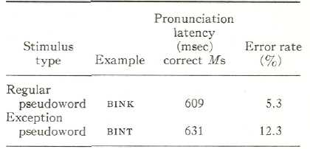
Results
Table 2 indicates correct pronunciation latencies and error rates for the regular and exception pseudowords in Experiment 2. (As before, the correct pronunciation was defined as the regular one.) Regular pseudowords were correctly pronounced in 609 msec compared to 631 msec for the exception pseudowords. This difference was significant treating both subjects, F (l, 15) = 5.62, p fc.05, and stimuli, F(1, 25) = 9.57, p < .01, as random factors. The means for each item are listed in the Appendix, Table A2.
These differences between the two classes of pseudowords were also manifested in error rates. Subjects made errors on 12.3% of the exception pseudoword trials, significantly more than the 5.3% errors for regular pseudowords, F (l, 15) = 16.98, p < .01. As in Experiment 1, the majority of the incorrect pronunciations for exception pseudowords (71% of the errors, or 8.7% of all trials) were errors of irregularization in which the pseudoword was pronounced with an irregular correspondence from a similar exception word.
Discussion
The results of Experiment 2 are simple but important. The latency advantage that regular pseudowords had over exception pseudowords in Experiment 1 was replicated, even when the experimental context was biased in favor of the use of abstract orthographic knowledge. The unsystematic priming introduced in Experiment 1 by randomly mixing words and pseudowords that resembled each other is negligible compared to the effects that arise during the process of pronouncing a letter string. There was no unambiguous evidence that readers use orthographic knowledge organized as correspondences between single letters or graphemes and single phonemes. If such abstract rules are used, they must be supplemented by more specific orthographic knowledge encoded as generalizations for particular multiletter spelling patterns. For example, readers might pronounce the novel word bint using a generalization about -int. Perhaps such independent representations of orthographic structure do not exist at all; the -INT rule might exist only implicitly in the integrated activation of words like hint, mint, and tint.
Experiment 3
Many current models of reading aloud (e.g., those of Baron, 1977a. 1977b; Gough & Cosky, 1977; Stanovich & Bauer, 1978) rely heavily on pronunciation latency differences between regular and exception words. The traditional distinction, as presented explicitly or implicitly in these models, is that exception words are those whose normal pronunciation differs from the regular one produced by abstract spelling-to-sound rules like those of Wijk (1966) or Venezky (1970). For example, have is an exception because it breaks the rule that a vowel followed by a simple consonant and then a final e corresponds to its "free" form (Venezky, 1970, p. 105). ² By this definition gave is regular, since it contains the free vowel in the context of the e marker.

² Note, however, that this rule breaking for have is consistent with the historical development in English orthography to add an e after what had been a final v or u. Beginning in the 15th and 16th centuries, scribes began adding the e to offset the graphic similarity of the V and u when they stood alone. Nevertheless, this subregularity from a descriptive standpoint is irrelevant to the reader who encounters the word as an unfamiliar letter string. Schane (1977) similarly resolves a number of the remaining exceptions to the final E pattern.

In Experiments 1 and 2, I used regular and exception letter strings, but my definitions were not based on grapheme-phoneme rules; I defined a word as an exception if it had a different spelling-to-sound structure than other words with the same vowel and terminal consonants. The results of these two experiments suggest that this classification may be more appropriate for psychology than the older distinction developed in taxonomic and historical linguistics. Experiments 1 and 2 imply a rather different partition of letter strings into those that are consistent and those that are inconsistent with the orthographic and phonological structure that they activate. The class of inconsistent words contains the exception words from before but also includes some words that would previously be classified as regular. For it to be consistent a regular word must have a unique pronunciation and follow the rules as before, but in addition it must embody the same orthographic regularities as other words that are likely to be activated in the course of reading that word. For example, have is both an exception by historical precedent and inconsistent by this new definition. In an activation framework, however, gave changes
classification from regular to inconsistent, since it shares orthographic features with have.
Classifying words as regular or exception is more than a preliminary to stimulus selection. Instead, it presupposes a theory of reading. In this experiment I tested a new three-way classification that reflects my theory of reading aloud: Words are not regular or exceptional in themselves, but only in the context of the other words that are activated in the course of reading them. This implies that words can be exceptions, regular and consistent, or regular and inconsistent. The activation explanation predicts that the two classes of words that produce inconsistent activation of orthographic and phonological structure will take longer to pronounce than the regular and consistent words.³
Method
Subjects. Sixteen students at the University of California, San Diego, received course credit or pay for the 40-min session. No subject had participated in either of the previous two experiments.
Stimuli and design. Each of 41 one-syllable exception words like have was paired with a regular and (necessarily) inconsistent word like wave; wave has a regular spelling-to-sound correspondence, even though it has the same vowel and terminal consonant as the exception word have, Next, to provide a close orthographic control that was regular and consistent, each exception and regular/inconsistent word was matched, when possible, with a regular /consistent word that differed only in the terminal consonant. For example, HAVE was paired with haze and wave with wade. While wave and haze both differ from have by only a single letter, I assume that two words that differ in their initial consonants are orthographically and phonologically closer than words that differ in medial consonants. The psychological saliency and developmental primacy of rhyme supports this assumption, haze and wade are both regular and consistent because they have the same regular spelling-to-sound correspondence as all the words ending in -aze and -ade. Across these four classes of words, initial consonants were used the same number of times to control for orthographic and acoustic onset characteristics. The stimuli for Experiment 3 are listed in the Appendix, Table A3.
The constraints of stimulus selection impose a slight bias against the predicted advantage for the regular/consistent words. While the median

³ An unfortunate symmetry here forces me to confess what I did with the "exception and consistent" words. These are words like laugh and schism, which are exceptions according to the traditional definition, but are consistent in my framework because they have no neighbors that fail to rhyme with them (most have no neighbors at all). For this last reason these words make poor stimuli. Since these words cannot be appropriately controlled, I have chosen to ignore them. However, since words like these are the bread and butter of the latency penalty for exception words in the literature, they lead to apparent counterexamples to the glib predictions here about the consequences of inconsistency. For example, the pseudoword maugh probably doesn't rhyme with laugh for many readers. Instead, maugh probably has the same vowel assignment as maude or mauve. This observation is not incompatible with the inconsistency principle, but it shows that it is less clear-cut than I have presented it. Nevertheless, if initial position neighbors exist, they are probably the most important ones. If there are no neighbors in that position, other words will play a larger role in determining a new pronunciation. A more general activation and synthesis model, with a broader experimental base, would allow for the contribution of neighbors in all positions, and would differentially weight them in different tasks.
Kucera and Francis (1967) word frequencies of the two regular word classes and the regular/inconsistent class were equivalent (14, 16, and 17), the exception words were somewhat more frequent (Mdn = 84).
Table 3
Results of Experiment 3

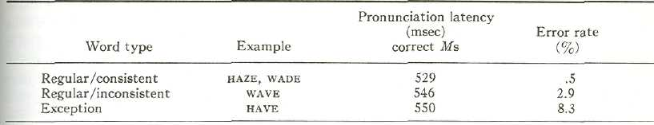
Procedure. The procedure and apparatus were the same as those in Experiments 1 and 2, except that subjects were informed that every letter string was a word. The 164 letter strings in the four groups produced by the matching procedure were presented in random order in lists filled to 240 words. The fillers were included to break up repetitions of letter strings with the same vowel and terminal consonants.
Results
Although it was necessary to have two groups of regular /consistent words to provide adequate controls for the exception and regular/inconsistent word sets, it is conceptually much simpler to treat the two control lists as a single control condition. Since the two word types did not differ at all in pronunciation latency (530 msec and 529 msec) or in error rates (both less than 1%), statistical analyses were carried out using a composite mean for each of the paired control words. Thus, means for exception words like have and regular/inconsistent words like wave were analyzed with a third composite mean formed by averaging the means for the control words HAZE and WADE.
Pronunciation latencies. Table 3 shows correct pronunciation latencies and error rates for the three types of letter strings in Experiment 3. Subjects initiated the correct pronunciation of exception words in 550 msec, while regular/inconsistent words took 546 msec. The regular/consistent words were pronounced considerably faster than either of these two types—in 529 msec. In general, words that activate an inconsistent body of orthographic and phonological knowledge took about 20 msec longer to pronounce than words that activate consistent information.
To determine the reliability of these three results, specific comparisons were conducted after two one-way analyses of variance were performed (over subjects and over items) to obtain the error terms. The item means are listed in the Appendix, Table A3. The 21-msec difference between exception words and regular/consistent words was significant both over subjects, F (l, 15) = 14.60, p < .005, and over items, F (1, 80) = 8.70, p < .005. The 17-msec penalty a regular word gets by being inconsistent with its orthographic neighbors also reached significance in both analyses: over subjects, F(1, 15) = 8.47, p < .025, and over items, F(l, 80) = 5.05, p < .05. Finally, exception and regular/inconsistent words taken together differed reliably from regular/consistent words: over subjects, F (l, 15) = 15.11, p < .005, and over items, F (l, 80) = 9.00, p < .005.
Errors. Error rates were affected by the classification of letter strings in approximately the same way as pronunciation latencies (See Table 3). When pronunciation information was consistent, performance was essentially error free, but inconsistency produced significantly more errors—5.6% of all trials, F (l, 15) = 12.14, p < .01. In addition, the pattern of errors for the exceptions and regular/inconsistent words, which activate an inconsistent body of orthographic and phonological knowledge, revealed that conflict in systematic mispronunciations. Subjects made errors on 8.4% of all exception word trials, and 84% of these errors were regularizations in which the incorrect regular pronunciation was given to the word. Similarly, 53% of the errors on regular/in-
consistent words were errors of irregularization, in which subjects gave a regular word the irregular vowel pronunciation embodied by an exception word that resembles it.
Discussion
In Experiment 3 there is a reliable difference in pronunciation latency between two types of regular words that differ only in the orthographic consistency of the words that they resemble. This penalty for words that have exceptional neighbors suggests that the historical definitions for regular and exception words may be inappropriate for psychological models of reading. A word need not be regular, even if it has a unique pronunciation that follows the rules. A word must also be consistent in pronunciation with the set of words that most closely resembles it for it to be truly regular.
General Discussion
In Experiment 1 regular pseudowords like hean (from dean) took less time to read aloud than exception pseudowords like heaf (from deaf). Experiment 2 showed that this difference was an inevitable result of the way that orthographic knowledge is organized and used, rather than an artifact of experimental context or subject strategy. In Experiment 3 regular and consistent words like wade took less time to pronounce than regular but inconsistent words like wave. Taken together, these reliable signs of conflicting orthographic knowledge suggest that a letter string is not read aloud by retrieving a single pronunciation from memory or by employing abstract spelling-to-sound rules. Instead, it appears that words and pseudowords are pronounced using similar kinds of knowledge: the pronunciations of words that resemble them and specific spelling-to-sound rules for multi-letter spelling patterns. Indeed, there is no unambiguous evidence for the use or orthographic rules as they are typically proposed.
How Specific Rules Might Work
If the idea is accepted that orthographic knowledge is organized and used as specific correspondences for multiletter spelling patterns, then there are some problems in accounting for the differences between consistent and inconsistent letter strings in these experiments. One possible theory might be that specific rules about inconsistent orthographic patterns would be harder to learn or would be more complex than specific rules about consistent patterns. Then, if rules learned from inconsistent examples take longer to invoke, specific rules could predict that exception pseudowords would take longer to pronounce than regular pseudo-words.
Nevertheless, for specific rules like these to assign a regular correspondence on some occasions and a number of distinct irregular ones in other situations (e.g. -omb, -ova -one, and other patterns had three different pronunciations in pseudowords in Experiments 1 and 2), it is necessary to postulate a separate specific rule for many spelling-to-sound correspondences embodied by only a single word. This explanation requires the proliferation of rules by the hundreds and perhaps thousands. While some theorists may call patterns of this level of generality "rules," in doing so they have sacrificed the economy that motivated rules in the first place. In addition, a workable system with such specific rules may be indistinguishable from an activation framework that in effect derives the relevant multiletter rule each time it is needed.
Activation Versus Analogy
Baron's (1977a) recent proposal for the use of analogies in pronouncing unfamiliar letter strings does not predict latency differences between the exception and regular pseudowords in Experiments 1 and 2. Baron has restricted this analogy strategy to the pronunciation of pseudowords, so his model would likewise be unable to predict a difference between inconsistent and consistent words in Experiment 3. This strategy uses existing words in a conscious one-at-a-time manner, while the latency differences are most easily explained in terms of conflict between competing pronunciations automatically activated at the same time.
Nevertheless, these difficulties are not difficulties in principle for Baron's analogy framework. If the retrieval of the stored pronunciation for a word itself is seen as the activation of its closest analogy, and many analogies are retrieved in parallel, an analogy model can account for the results of these three experiments. Since so much analogizing is unlikely to take place as a conscious strategy within the half-second needed to pronounce a word or pseudoword, analogies would have to be activated automatically.
The fundamental difference between activation and analogy may reduce to an effect of the set or context in which a reader uses knowledge of spelling-to-sound structure. When subjects are instructed to make explicit use of their orthographic knowledge, as they are in Baron's experiments (1977a, 1977b, 1979), they seem to be capable of consciously retrieving words or specific multiletter rules that they can use to pronounce unfamiliar letter strings—a process that is aptly described as analogy. On the other hand, in situations where subjects are not given explicit analogy instructions, but are asked to make rapid implicit use of their knowledge of spelling-to-sound structure, as they were in the three experiments reported in this article, the automatic availability of specific pronunciation information is most appropriately described as activation.
The Regular—Exception Distinction
In an activation framework, a word is not regular or exceptional only in terms of its own spelling-to-sound correspondence. Rather, a word is consistent or inconsistent with the orthographic and phonological structure that it activates. Regular and exception words are pronounced using the same kinds of knowledge. Exception words are simply those words whose phonological structures are likely to conflict most strongly with other activated information. The traditional distinction may suffice for historical or taxonomic approaches to orthography, but in the activation framework regular and exception words are not in themselves fundamentally different.
This claim contrasts with those of Baron and Strawson (1976) and Coltheart (1978), who argue for the psychological validity of the regular-exception classification. In their models, exceptions are explicitly tagged or flagged, marking them literally as exceptions to the rules. A similar principle is incorporated in the grammar proposed by Chomsky and Halle (1968), in which every exception to a phonological rule must be explicitly marked to block the rule from applying. Admittedly, though, it is not clear how seriously Chomsky and Halle intend their description as a psychological one.
Nevertheless, if exceptions were explicitly marked, the processes of activation and synthesis might use this information in constructing a pronunciation for a novel letter string. This might predict that exception pseudowords would take longer to pronounce than regular pseudowords, but they would always be pronounced regularly, since inappropriate information would be rejected. Yet exception pseudowords were pronounced irregularly over 17% of the time in Experiment 1 and about 9% of the time in Experiment 2. The availability of such exceptional correspondences implies that the classification of words as regular or exception is not represented in the lexicon: "Exceptions" are not that exceptional.
References
Baker, R., & Smith, P. A psycholinguistic study of English stress assignment rules. Language and Speech, 1976, 19, 9-27.
Baron, J. Mechanisms for pronouncing printed words: Use and acquisition. In D. LaBerge & S. Samuels (Eds.), Basic processes in reading: Perception and comprehension. Hillsdale, N.J.: Erlbaum, 1977. (a)
Baron, J. What we might know about orthographic rules. In S. Dornic (Ed.), Attention and performance VI. Hillsdale, N.J.: Erlbaum, 1977. (b)
Baron, J. Orthographic and word-specific mechanisms in children's reading of words. Child Development, 1979, 50, 60-72.
Baron, J., & Strawson, C, Use of orthographic and word-specific knowledge in reading words aloud. Journal of Experimental Psychology: Human Perception and Performance, 1976, 2, 386-393.
Bradshaw, J. Three interrelated problems in reading: A review. Memory & Cognition, 1975, 3, 123-134.
Brooks, L. Non-analytic correspondences and pattern in word pronunciation. In J. Requin (Ed.), Attention and Performance VII. Hillsdale, NJ: Erlbaum, 1977. (a)
Brooks, L. Visual pattern in fluent word identification. In A. Reber & D. Scarborough (Eds.). Toward a psychology of reading. Hillsdale, NJ: Erlbaum, 1977. (b)
Brooks, L. Nonanalytic concept formation and memory for instances. In E. Rosch & B. Lloyd (Eds.), Cognition and categorization. Potomac, Md.: Erlbaum, 1978.
Chomsky, N., & Halle, M. The sound pattern of English. New York: Harper & Row, 1968.
Coltheart, M. Lexical access in simple reading tasks. In G. Underwood (Ed.), Strategies of information processing. London: Academic Press, 1978.
Forster, K., & Chambers, S. Lexical access and naming time. Journal of Verbal Learning and Verbal Behavior, 1973, 12, 627-635.
Frederiksen, J., & Kroll, J. Spelling and sound: Approaches to the internal lexicon. Journal of Experimental Psychology: Human Perception and Performance, 1976, 2, 361-379.
Gough, P., & Cosky, M. One second of reading again. In N. Castellan, D. Pisoni, & G. Potts (Eds.), Cognitive theory (Vol. 2). Hillsdale, NJ.: Erlbaum, 1977.
Hawkins, H., Reicher, G., Rogers, M., & Peterson, L. Flexible coding in word recognition. Journal of Experimental Psychology: Human Perception and Performance, 1976, 2, 380-385.
Kucera, H., & Francis, W. Computational analysis of present-day American English. Providence, R.I.: Brown University Press, 1967.
Marshall, J. Neuropsychological aspects of orthographic representation. In R. Wales & E. Walker (Eds.), New approaches to language mechanisms. Amsterdam: North Holland, 1976.
Mason, M. From print to sound in mature readers as a function of reader ability and two forms of orthographic regularity. Memory & Cognition. 1978, 6, 568-581.
Meyer, D., Schvaneveldt, R., & Ruddy, M. Functions of graphemic and phonemic codes in visual word recognition. Memory & Cognition, 1974, 2, 309-321.
Ohala, J. Experimental historical phonology. In J. Anderson & C. Jones (Eds.), Historical linguistics H: Theory and description in phonology. Amsterdam: North Holland, 1974.
Patterson, K., & Marcel, A. Aphasia, dyslexia, and the phonological coding of written words. Quarterly Journal of Experimental Psychology, 1977. 29, 307-318.
Saffran, E., & Marin, O. Reading without phonology: Evidence from aphasia. Quarterly Journal of Experimental Psychology, 1977, 29, 515-525.
Schane, S. Rule breaking in English spelling: A study of final E. In P. Hopper (Ed.), Studies in descriptive and historical linguistics: Festschrift for Winfred P. Lehmann, Amsterdam: John Benjamins, 1977.
Smith, P., & Baker, R. The influence of English spelling patterns on pronunciation. Journal oj Verbal Learning and Verbal Behavior, 1975, 15, 267-285.
Spoehr, K. Phonological encoding in visual word recognition. Journal of Verbal Learning and Verbal Behavior, 1978, 17, 127-141.
Spoehr, K., & Smith, E. The role of orthographic and phonotactic rules in perceiving letter patterns. Journal of Experimental Psychology: Human Perception and Performance, 1975, 1, 21-34.
Stanovich, K., & Bauer, D. Experiments on the spelling-to-sound regularity effect in word recognition. Memory & Cognition, 1978, 6, 410-415.
Steinberg, D., & Krohn, R. The psychological validity of Chomsky and Halle's vowel shift rule. In E. Koerner, J. Odmark, & J. Shaw (Eds.), The transformation-generative paradigm and modern linguistic theory. Amsterdam: John Benjamins, 1975.
Theios, J., & Muise, J. The word identification process in reading. In N. Castellan, D. Pisoni, & G. Potts (Eds.), Cognitive thcoy (Vol. 2). Hillsdale, NJ: Erlbaum, 1977.
Venezky, R. English orthography: Its graphical structure and its relation to sound. Reading Research Quarterly, 1967, 2, 75-105.
Venezky, R. The structure of English orthography. The Hague: Mouton, 1970.
Wijk, A. Rules of pronunciation for the English language. London: Oxford University Press, 1966.
Zurif, E., & Caramazza, A. Psycholinguistic studies in aphasia: Studies in syntax and semantics. In H. Whitaker & H. A. Whitaker (Eds.), Studies in neurolinguistics (Vol. I). New York: Academic Press, 1976.

Table Al
Item Means for Correct Pronunciation Latencies (in msec) in Experiment 1

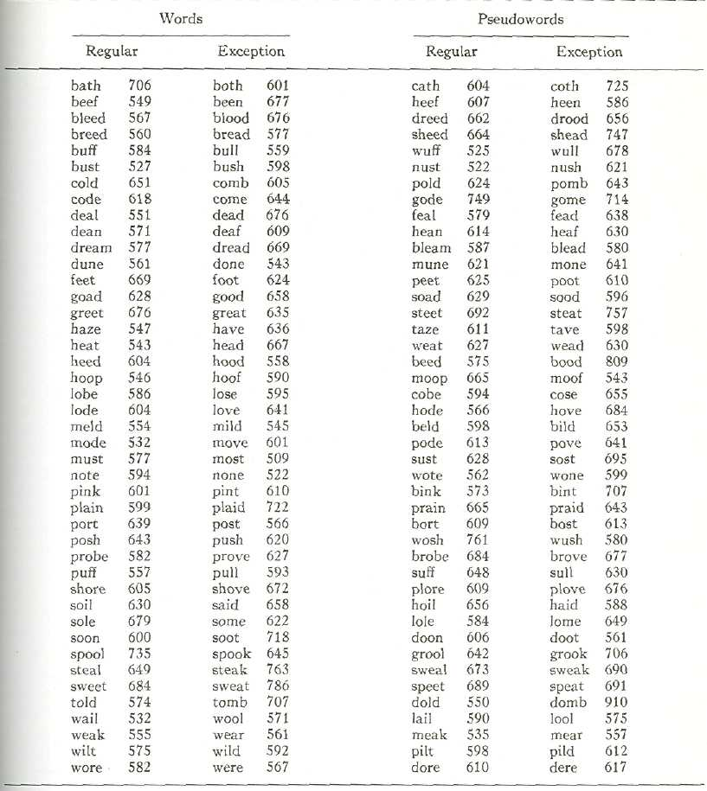

Table A2
Items Means for Correct Pronunciation-Latencies {in msec) in Experiment 2

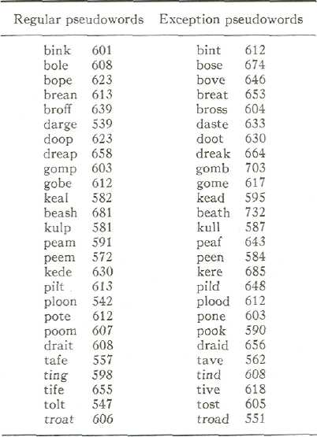

Table A3
Item Means for Correct Pronunciation Latencies (in msec) in Experiment 3
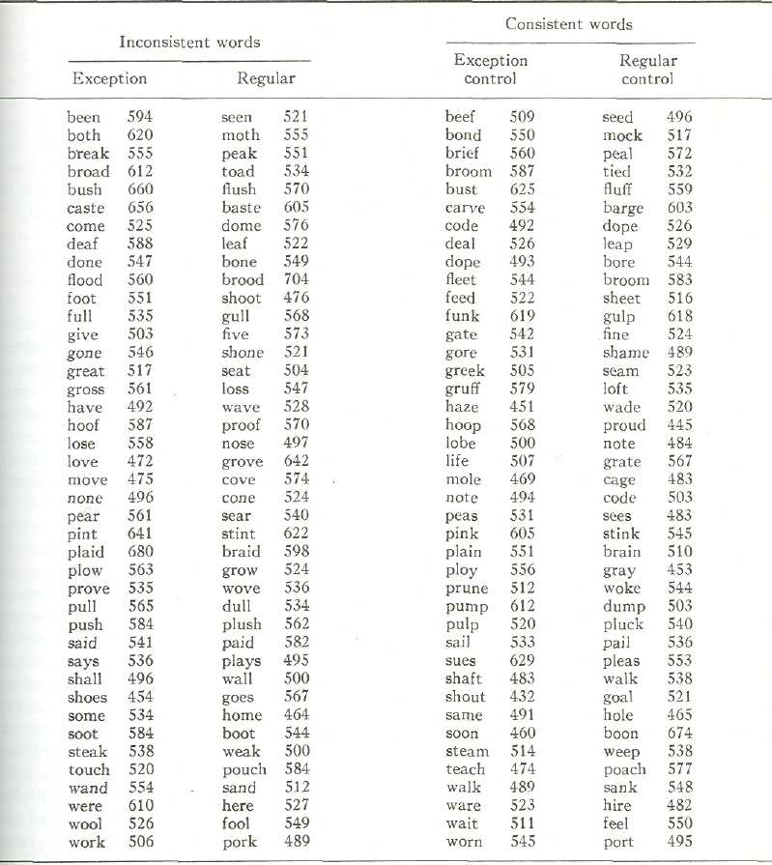

Received Octorber 6, 1978.

